|  |  |  |
| --- | --- | --- |
| Лабораторная работа №3  Физическое проектирование базы данных | Ф.И.О. | Сидский Н. А. |
| Группа | ИВТ-261 |
| Преподаватель | Аль-Мерри Гаис М. С. |
| Дата сдачи | 16.04.2024 |

Реляционная схема из лабораторной работы №2

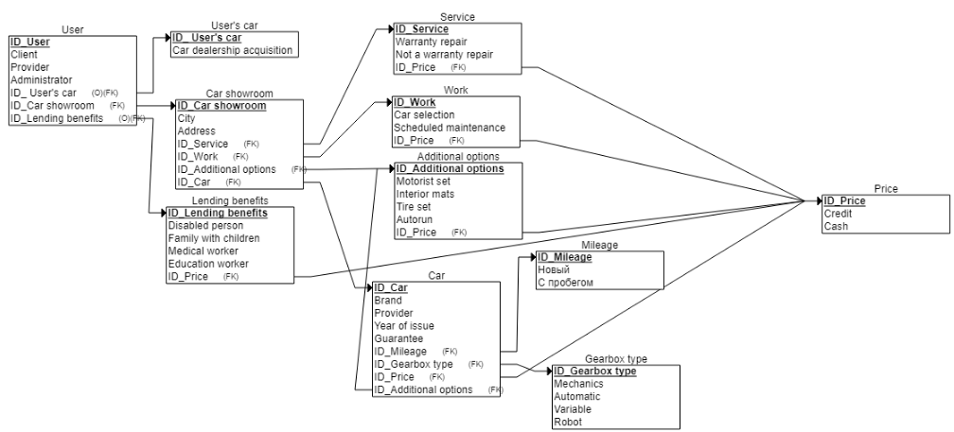

Полученная реляционная схема из pgAdmin

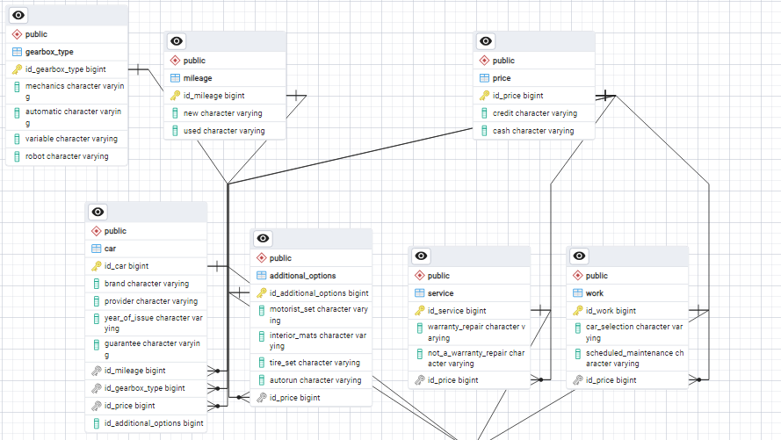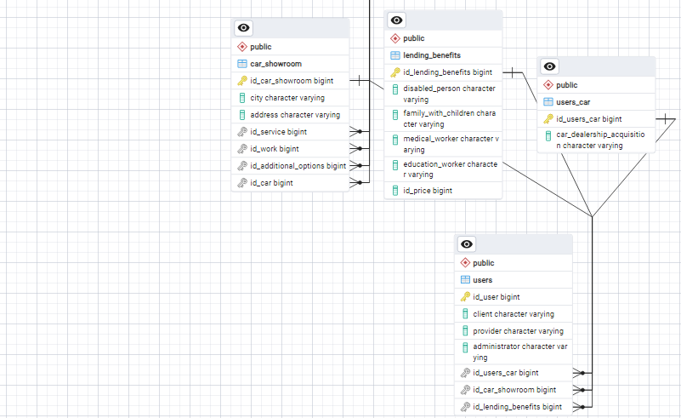

Данные реляционные схемы полностью совпадают.

Данные, хранящиеся в данной БД:

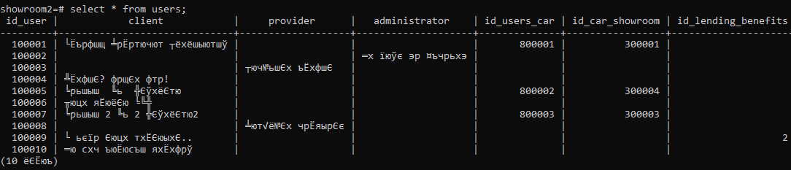

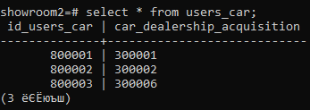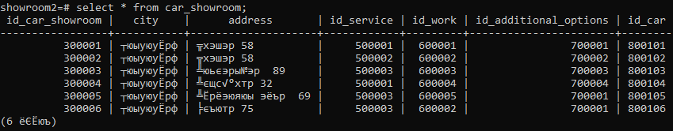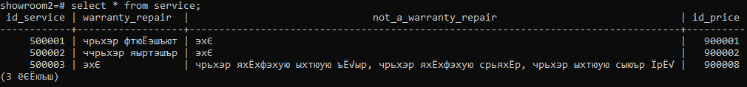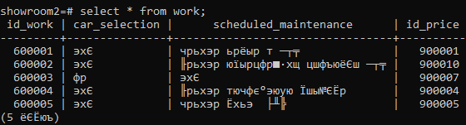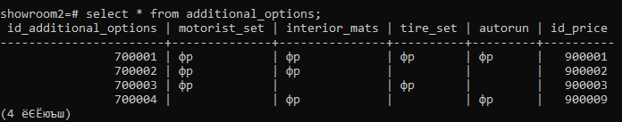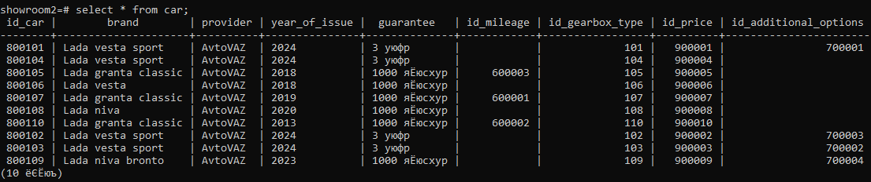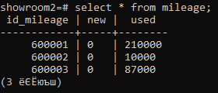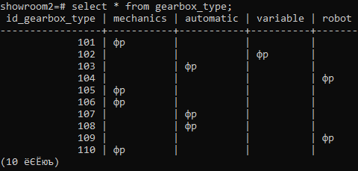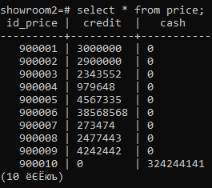

Реляционная схема одногруппника:

Реализация БД одногруппника с помощью скриптов:

-- создаём таблицы с колонками

create table cargo (

cargo_id INT,

cargo_name varchar,

weight DECIMAL(18,2),

fk_order int,

PRIMARY KEY (cargo_id)

);

insert into cargo (cargo_id, cargo_name, weight, fk_order) values (1, 1, 1, 1);

insert into cargo (cargo_id, cargo_name, weight, fk_order) values (2, 2, 2, 2);

insert into cargo (cargo_id, cargo_name, weight, fk_order) values (3, 3, 3, 3);

insert into cargo (cargo_id, cargo_name, weight, fk_order) values (4, 4, 4, 4);

insert into cargo (cargo_id, cargo_name, weight, fk_order) values (5, 5, 5, 5);

insert into cargo (cargo_id, cargo_name, weight, fk_order) values (6, 6, 6, 6);

insert into cargo (cargo_id, cargo_name, weight, fk_order) values (7, 7, 7, 7);

insert into cargo (cargo_id, cargo_name, weight, fk_order) values (8, 8, 8, 8);

insert into cargo (cargo_id, cargo_name, weight, fk_order) values (9, 9, 9, 9);

insert into cargo (cargo_id, cargo_name, weight, fk_order) values (10, 10, 10, 10);

--ALTER TABLE cargo ADD CONSTRAINT pk_cargo PRIMARY KEY (cargo_id); -- создали первичным ключом cargo_id

create table transport_on_route (

transport_on_route_id INT,

fk_route INT,

fk_transport_number varchar,

PRIMARY KEY (transport_on_route_id)

);

insert into transport_on_route (transport_on_route_id, fk_route, fk_transport_number) values (200000, 500000, 400000);

insert into transport_on_route (transport_on_route_id, fk_route, fk_transport_number) values (200001, 500001, 400001);

insert into transport_on_route (transport_on_route_id, fk_route, fk_transport_number) values (200002, 500002, 400002);

insert into transport_on_route (transport_on_route_id, fk_route, fk_transport_number) values (200003, 500003, 400003);

insert into transport_on_route (transport_on_route_id, fk_route, fk_transport_number) values (200004, 500004, 400004);

insert into transport_on_route (transport_on_route_id, fk_route, fk_transport_number) values (200005, 500005, 400005);

insert into transport_on_route (transport_on_route_id, fk_route, fk_transport_number) values (200006, 500006, 400006);

insert into transport_on_route (transport_on_route_id, fk_route, fk_transport_number) values (200007, 500007, 400007);

insert into transport_on_route (transport_on_route_id, fk_route, fk_transport_number) values (200008, 500008, 400008);

insert into transport_on_route (transport_on_route_id, fk_route, fk_transport_number) values (200009, 500009, 400009);

--ALTER TABLE transport_on_route ADD CONSTRAINT pk_transport_on_route PRIMARY KEY (transport_on_route_id); -- создали первичным ключом transport_on_route_id

create table ordder (

order_id INT,

price DECIMAL (18,2),

total_weight DECIMAL (18,2),

status varchar(40),

fk_email varchar(100),

fk_route_id INT,

PRIMARY KEY (order_id)

);

insert into ordder (order_id, price, total_weight, status, fk_email, fk_route_id) values (300000, 12, 11, 'ykrali', 'q@ya.ru', 500000);

insert into ordder (order_id, price, total_weight, status, fk_email, fk_route_id) values (300001, 12, 11, 'ykrali', 'w@ya.ru', 500001);

insert into ordder (order_id, price, total_weight, status, fk_email, fk_route_id) values (300002, 12, 11, 'ykrali', 'e@ya.ru', 500002);

insert into ordder (order_id, price, total_weight, status, fk_email, fk_route_id) values (300003, 12, 11, 'ykrali', 'r@ya.ru', 500003);

insert into ordder (order_id, price, total_weight, status, fk_email, fk_route_id) values (300004, 12, 11, 'ykrali', 't@ya.ru', 500004);

insert into ordder (order_id, price, total_weight, status, fk_email, fk_route_id) values (300005, 12, 11, 'ykrali', 'y@ya.ru', 500005);

insert into ordder (order_id, price, total_weight, status, fk_email, fk_route_id) values (300006, 12, 11, 'ykrali', 'u@ya.ru', 500006);

insert into ordder (order_id, price, total_weight, status, fk_email, fk_route_id) values (300007, 12, 11, 'ykrali', 'i@ya.ru', 500007);

insert into ordder (order_id, price, total_weight, status, fk_email, fk_route_id) values (300008, 12, 11, 'ykrali', 'o@ya.ru', 500008);

insert into ordder (order_id, price, total_weight, status, fk_email, fk_route_id) values (300009, 12, 11, 'ykrali', 'p@ya.ru', 500009);

--ALTER TABLE ordder ADD CONSTRAINT pk_ordder PRIMARY KEY (order_id); -- создали первичным ключом order_id

create table transport (

transport_number INT,

lifting_capacity DECIMAL (100,2),

fk_email varchar(100),

fk_brand_id INT,

--fk_brand_id INT,

PRIMARY KEY (transport_number)

);

insert into transport (transport_number, lifting_capacity, fk_email, fk_brand_id) values (400000, 43, 'q@ya.ru', 600000);

insert into transport (transport_number, lifting_capacity, fk_email, fk_brand_id) values (400001, 33, 'w@ya.ru', 600001);

insert into transport (transport_number, lifting_capacity, fk_email, fk_brand_id) values (400002, 43, 'e@ya.ru', 600002);

insert into transport (transport_number, lifting_capacity, fk_email, fk_brand_id) values (400003, 46, 'r@ya.ru', 600003);

insert into transport (transport_number, lifting_capacity, fk_email, fk_brand_id) values (400004, 43, 't@ya.ru', 600004);

insert into transport (transport_number, lifting_capacity, fk_email, fk_brand_id) values (400005, 43, 'y@ya.ru', 600005);

insert into transport (transport_number, lifting_capacity, fk_email, fk_brand_id) values (400006, 43, 'u@ya.ru', 600006);

insert into transport (transport_number, lifting_capacity, fk_email, fk_brand_id) values (400007, 48, 'i@ya.ru', 600007);

insert into transport (transport_number, lifting_capacity, fk_email, fk_brand_id) values (400008, 43, 'o@ya.ru', 600008);

insert into transport (transport_number, lifting_capacity, fk_email, fk_brand_id) values (400009, 43, 'p@ya.ru', 600009);

--ALTER TABLE transport ADD CONSTRAINT pk_transport PRIMARY KEY (transport_number); -- создали первичным ключом transport_number

create table route (

route_id INT,

starting_point int,

end_point int,

PRIMARY KEY (route_id)

);

insert into route (route_id, starting_point, end_point) values (500000, 100, 200);

insert into route (route_id, starting_point, end_point) values (500001, 101, 201);

insert into route (route_id, starting_point, end_point) values (500002, 102, 202);

insert into route (route_id, starting_point, end_point) values (500003, 103, 203);

insert into route (route_id, starting_point, end_point) values (500004, 104, 204);

insert into route (route_id, starting_point, end_point) values (500005, 105, 205);

insert into route (route_id, starting_point, end_point) values (500006, 106, 206);

insert into route (route_id, starting_point, end_point) values (500007, 107, 207);

insert into route (route_id, starting_point, end_point) values (500008, 108, 208);

insert into route (route_id, starting_point, end_point) values (500009, 109, 209);

--ALTER TABLE route ADD CONSTRAINT pk_route PRIMARY KEY (route_id); -- создали первичным ключом route_id

create table users (

email varchar(100),

pasword varchar(100),

surname varchar(40),

first_name varchar(40),

second_name varchar(40),

rolle varchar(200),

PRIMARY KEY (email)

);

insert into users (email, pasword, surname, first_name, second_name, rolle) values ('q@ya.ru', 'q', 'q', 'qq', 'qqq', 'user');

insert into users (email, pasword, surname, first_name, second_name, rolle) values ('w@ya.ru', 'w', 'w', 'qw', 'qqw', 'user');

insert into users (email, pasword, surname, first_name, second_name, rolle) values ('e@ya.ru', 'e', 'e', 'qe', 'qqe', 'user');

insert into users (email, pasword, surname, first_name, second_name, rolle) values ('r@ya.ru', 'r', 'r', 'qr', 'qqr', 'user');

insert into users (email, pasword, surname, first_name, second_name, rolle) values ('t@ya.ru', 't', 't', 'qt', 'qqt', 'user');

insert into users (email, pasword, surname, first_name, second_name, rolle) values ('y@ya.ru', 'y', 'y', 'qy', 'qqy', 'user');

insert into users (email, pasword, surname, first_name, second_name, rolle) values ('u@ya.ru', 'u', 'u', 'qu', 'qqu', 'user');

insert into users (email, pasword, surname, first_name, second_name, rolle) values ('i@ya.ru', 'i', 'i', 'qi', 'qqi', 'user');

insert into users (email, pasword, surname, first_name, second_name, rolle) values ('o@ya.ru', 'o', 'o', 'qo', 'qqo', 'user');

insert into users (email, pasword, surname, first_name, second_name, rolle) values ('p@ya.ru', 'p', 'p', 'qp', 'qqp', 'user');

--ALTER TABLE users ADD CONSTRAINT pk_users PRIMARY KEY (email); -- создали первичным ключом email

create table brand (

brand_id INT,

brand_name varchar(100),

PRIMARY KEY (brand_id)

);

insert into brand (brand_id, brand_name) values (600000, 'q');

insert into brand (brand_id, brand_name) values (600001, 'w');

insert into brand (brand_id, brand_name) values (600002, 'e');

insert into brand (brand_id, brand_name) values (600003, 'r');

insert into brand (brand_id, brand_name) values (600004, 't');

insert into brand (brand_id, brand_name) values (600005, 'y');

insert into brand (brand_id, brand_name) values (600006, 'u');

insert into brand (brand_id, brand_name) values (600007, 'i');

insert into brand (brand_id, brand_name) values (600008, 'o');

insert into brand (brand_id, brand_name) values (600009, 'p');

--ALTER TABLE brand ADD CONSTRAINT pk_brand PRIMARY KEY (brand_id); -- создали первичным ключом brand_id

create table color (

color_id INT,

color_name varchar(100),

PRIMARY KEY (color_id)

);

insert into color (color_id, color_name) values (700000, 'q');

insert into color (color_id, color_name) values (700001, 'w');

insert into color (color_id, color_name) values (700002, 'e');

insert into color (color_id, color_name) values (700003, 'r');

insert into color (color_id, color_name) values (700004, 't');

insert into color (color_id, color_name) values (700005, 'y');

insert into color (color_id, color_name) values (700006, 'u');

insert into color (color_id, color_name) values (700007, 'i');

insert into color (color_id, color_name) values (700008, 'o');

insert into color (color_id, color_name) values (700009, 'p');

--ALTER TABLE color ADD CONSTRAINT pk_color PRIMARY KEY (color_id); -- создали первичным ключом color_id

create table destination (

destination_id INT,

street varchar(100),

fk_city_id INT,

house_number int,

PRIMARY KEY (destination_id)

);

insert into destination (destination_id, street, fk_city_id, house_number) values (800000, 'q', 900000, 1);

insert into destination (destination_id, street, fk_city_id, house_number) values (800001, 'w', 900001, 1);

insert into destination (destination_id, street, fk_city_id, house_number) values (800002, 'e', 900002, 1);

insert into destination (destination_id, street, fk_city_id, house_number) values (800003, 'r', 900003, 1);

insert into destination (destination_id, street, fk_city_id, house_number) values (800004, 't', 900004, 1);

insert into destination (destination_id, street, fk_city_id, house_number) values (800005, 'y', 900005, 1);

insert into destination (destination_id, street, fk_city_id, house_number) values (800006, 'u', 900006, 1);

insert into destination (destination_id, street, fk_city_id, house_number) values (800007, 'i', 900007, 1);

insert into destination (destination_id, street, fk_city_id, house_number) values (800008, 'o', 900008, 1);

insert into destination (destination_id, street, fk_city_id, house_number) values (800009, 'p', 900009, 1);

--ALTER TABLE destination ADD CONSTRAINT pk_destination PRIMARY KEY (destination_id); -- создали первичным ключом destination_id

create table city (

city_id INT,

city_name varchar(100),

PRIMARY KEY (city_id)

);

insert into city (city_id, city_name) values (900000, 'q');

insert into city (city_id, city_name) values (900001, 'w');

insert into city (city_id, city_name) values (900002, 'e');

insert into city (city_id, city_name) values (900003, 'r');

insert into city (city_id, city_name) values (900004, 't');

insert into city (city_id, city_name) values (900005, 'y');

insert into city (city_id, city_name) values (900006, 'u');

insert into city (city_id, city_name) values (900007, 'i');

insert into city (city_id, city_name) values (900008, 'o');

insert into city (city_id, city_name) values (900009, 'p');

--ALTER TABLE city ADD CONSTRAINT pk_city PRIMARY KEY (city_id); -- создали первичным ключом city_id

--добавить данные

Схема базы данных одногруппника, полученная в графической оболочке:

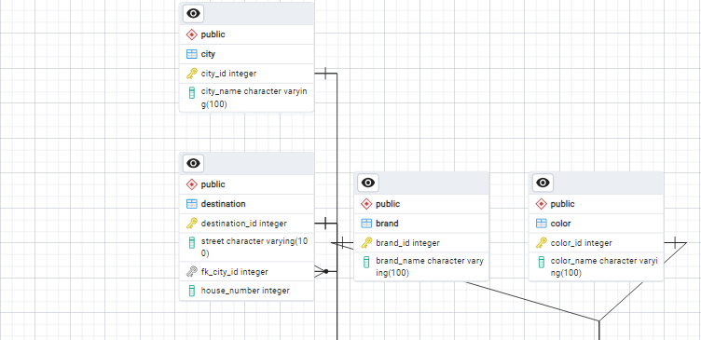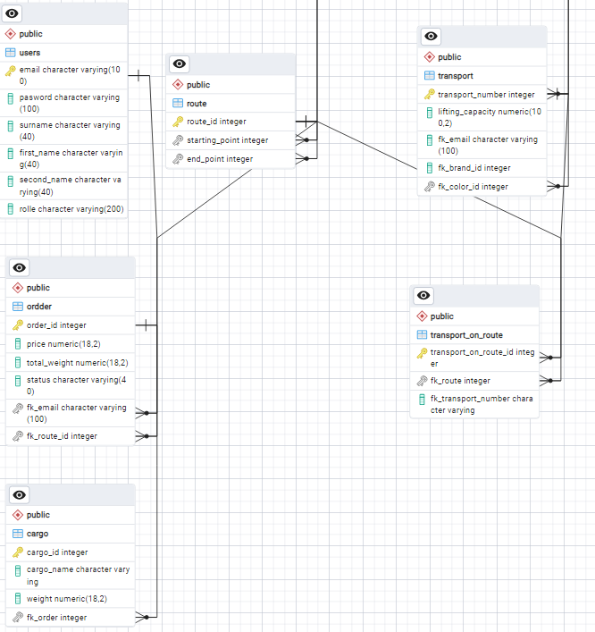

Запросы на изменение таблиц:

1. Добавление столбца:
   * 
   * Изображение выглядит как текст, Шрифт, снимок экрана, типография

     Автоматически созданное описание
2. Изменение столбца:
   * 
   * Изображение выглядит как текст, снимок экрана, Шрифт, линия

     Автоматически созданное описание
   * Изображение выглядит как текст, снимок экрана, Шрифт, линия

     Автоматически созданное описание
3. Удаление столбца:
   * 
   * Изображение выглядит как текст, Шрифт, снимок экрана, типография

     Автоматически созданное описание
4. Добавление внешнего ключа:
   * 
   * 
5. Удаление внешнего ключа:
   * + 
     + 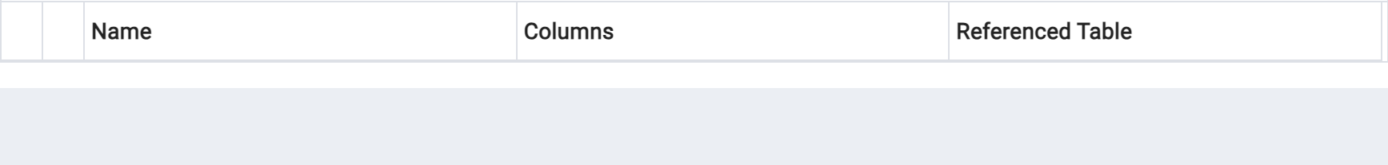
6. Добавление первичного ключа:
   * 
   * 
7. Удаление первичного ключа:
   * 
   * 
8. Добавление, изменение или удаление другого ограничения (например, UNIQUE или CHECK):
   * 
   * 
9. **RENAME:**

* 
* **Изображение выглядит как текст, снимок экрана, дисплей, число

  Автоматически созданное описание Изображение выглядит как текст, снимок экрана, дисплей, Шрифт

  Автоматически созданное описание**
* **-------------------------------------------------------------------------------**
* **Изображение выглядит как текст, Шрифт, снимок экрана, белый

  Автоматически созданное описание**
* **Изображение выглядит как текст, снимок экрана, Шрифт, линия

  Автоматически созданное описание Изображение выглядит как текст, снимок экрана, Шрифт, число

  Автоматически созданное описание**

Отчет лабораторной работы:

1. 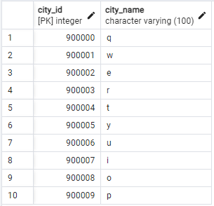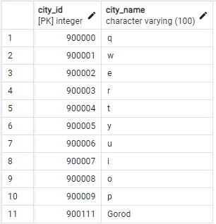
2. 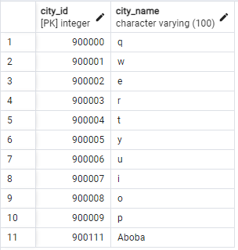
3. 